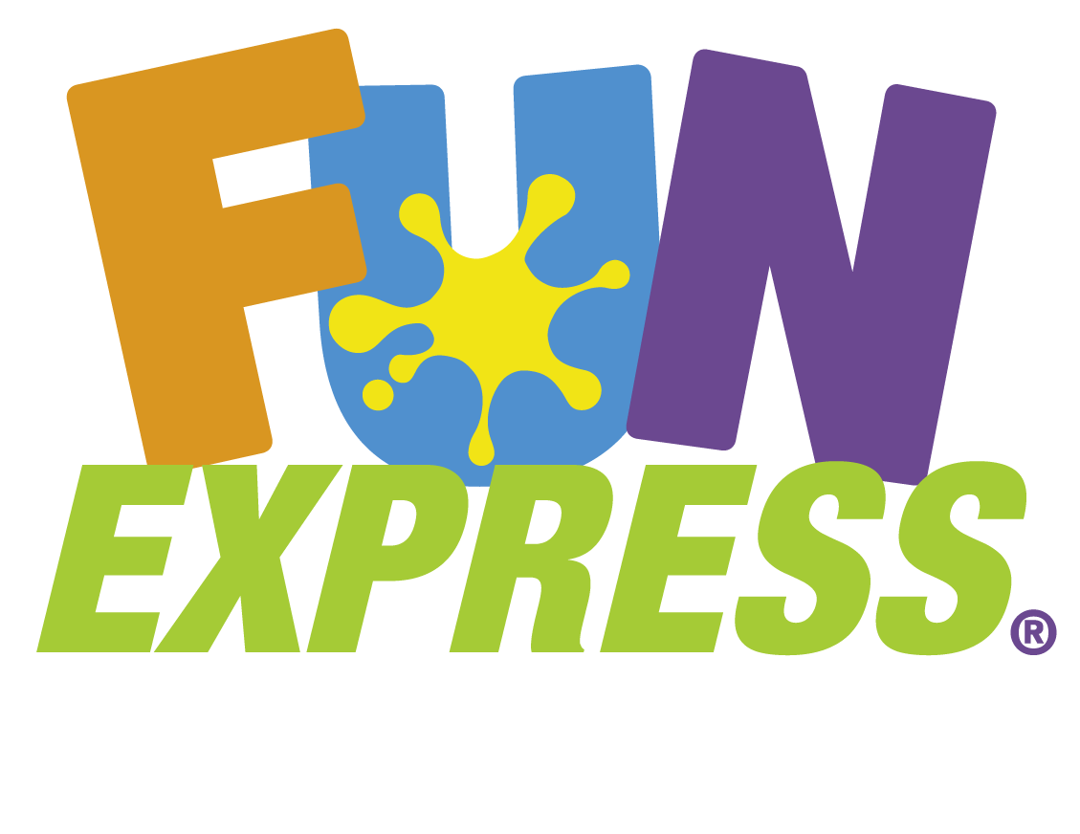

W hen it comes to fun, we're all business.

PAPER FIRST AFFILIATES – Purchase Program 2022

** EVERYDAY Orders:
- Receive Case Pricing, less 5%. Your line item will reflect the immediate discount.
- Free Freight honored for orders of $300.00 or more, per location, UPS Ground Shipments, delivered within the Continental USA.

** EARLY Purchase Programs – noted below:

ADDITIONAL 5% DISCOUNT applied, if the order is received by the ‘Order to FX’ date.
- Free Freight honored for orders >$300.00, per location, UPS Ground, delivered within the Continental USA.
- Qualified accounts can receive NET90 TERMS, based on the recommended Ship Date. If an earlier Ship Date is requested, Net 90 Terms will begin from the requested Ship Date.
- The Keycode must be included with each Early Purchase Program Order submitted.
- The Early Purchase Program is only available to customers that have brick ‘n mortar retail stores. E-commerce businesses are not eligible for these benefits.

Catalog Number | Arrival Date | 2022/2023 Seasonal/Catalog | 2022/2023 Holiday Date | Order to FX by: | Ship Date: | Invoice Due Date: | Key Code | Keycode Begin Date | Keycode End Date
9224X | 10/3/2022 | Graduation | May/June 2022 | 2/15/2022 | 3/15/2022 | 6/15/2022 | 22RGRAD | 1/15/2022 | 3/16/2022
9210X | 5/2/2022 | Halloween/Pink Ribbon* | 10/31/22 Monday | 3/1/2022 | 8/15/2022 | 11/27/2022 | 22RHALL | 1/31/2022 | 4/3/2022
9205X | 2/21/2022 | FX Main Playbook | Everyday Promo | 3/1/2022 | 4/1/2022 | 7/1/2022 | 22EVRDY | 1/31/2022 | 4/3/2022
9205X | 2/21/2022 | Patriotic | 07/04/2022 Monday | 4/5/2022 | 5/1/2022 | 8/1/2020 | 22PATR | 3/16/2022 | 5/5/2022
9210X | 5/2/2022 | Christmas | 12/25/2022 Sunday | 8/30/2022 | 10/26/2022 | 1/26/2022 | 22RCHRI | 8/1/2022 | 9/14/2022
9224X | 10/3/2022 | Mardi Gras | 03/01/2022 Tuesday | 10/18/2022 | 12/15/2022 | 3/15/2023 | 22RSPR1 | 9/18/2022 | 11/16/2022
9224X | 10/3/2022 | Valentine | 2/14/2022 Tuesday | 10/18/2022 | 12/15/2022 | 3/15/2023 | 22RSPR1 | 9/18/2022 | 11/16/2022
9224X | 10/3/2022 | St. Pat's | 03/17/2022 Friday | 10/18/2022 | 1/15/2022 | 4/15/2023 | 22RSPR2 | 9/18/2022 | 11/16/2022
9224X | 10/3/2022 | Easter | 04/17/2022 Sunday | 10/18/2022 | 1/15/2022 | 4/15/2023 | 22RSPR2 | 9/18/2022 | 11/16/2022
 |  | *Pink Ribbon will be in 9205X and online

For additional information please contact your sales representative or;
Fun Express Customer Support
800.228.0096
Orders@FunExpress.com

Submit all payments to: Fun Express LLC Lock Box P.O.Box 77120 Minneapolis MN 55480-7702
Orders must be paid by the Invoice Due Date to receive Discounts and/or Net Terms.

